**PRODUCT SALES ANALYSIS**

**Team memebers**

* **511921104008 - Arshvanth**
* **511921104040 - Musharaf Sharif**
* **511921104037 - Moha Rishi**
* **511921104017- Dharneshwaran**

**Phase 2 submission document**

**Project Name : product sales analysis**

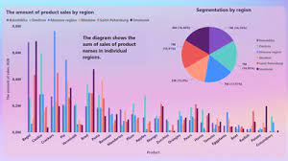

**INTRODUCTION :**

**Product sales analysis is a crucial process for businesses to understand their sales performance and make informed decisions.**

**By following these steps, you can conduct a thorough product sales analysis that helps your business make data-driven decisions and improve sales performance.**

**STEP 1: Gather Data**

**Collect all relevant data about your product sales. This includes sales records, transaction data, customer information, and any other relevant data sources. Ensure data accuracy and completeness.**

**STEP 2: Define Objectives**

**Clearly define the objectives of your sales analysis. Are you trying to identify top-selling products, understand seasonality, or optimize pricing strategies? Having clear objectives will guide your analysis.**

**STEP 3: Data Cleaning and Preparation**

**Clean and preprocess the data to remove errors, duplicates, and inconsistencies. Make sure all data is in a consistent format. This may involve data normalization, handling missing values, and data transformation.**

**STEP 4: Segmentation**

**Divide your sales data into meaningful segments. This can include product categories, geographical regions, customer demographics, or any other relevant factors. Segmentation helps identify trends and patterns.**

**STEP 5: Calculate Key Metrics**

**Calculate essential sales metrics, such as total revenue, sales volume, average order value, and gross margin. These metrics provide a baseline for your analysis.**

**STEP 6 : Time Series Analysis**

**Analyze sales data over time to identify trends, seasonality, and growth patterns. Use techniques like moving averages and time series decomposition to gain insights.**

**STEP 7 : Product Performance Analysis**

**Evaluate the performance of individual products. Identify best-selling products, slow-moving items, and those with the highest profit margins. This helps in inventory management and product development decisions.**

**STEP 8 : Customer Analysis**

**Analyze customer behavior. Identify your top customers, their purchasing habits, and lifetime value. This can help in customer retention and acquisition strategies.**

**STEP 9 : Market and Competition Analysis**

**Research the market and your competitors. Compare your product sales with market trends and competitor performance to identify opportunities and threats.**

**STEP 10 : Pricing Analysis**

**Analyze the impact of pricing on sales. Determine if price changes affect sales volumes and margins. Test different pricing strategies if needed.**

**STEP 11: Promotions and Campaign Analysis**

**Analyze the impact of marketing promotions and campaigns on product sales. Identify which marketing efforts are the most effective in driving sales.**

**STEP 12 :Inventory Management**

**Use sales analysis to optimize inventory levels. Ensure that you have enough stock of popular products and minimize excess inventory of slow-moving items.**

**STEP 13 : Visualize Data**

**Create charts, graphs, and visual representations of the data to make it easier to understand and share insights with stakeholders. Tools like Excel, Tableau, or Python libraries like Matplotlib and Seaborn can be useful for this.**

**STEP 14 : Draw Insights and Conclusions**

**Based on your analysis, draw meaningful insights and conclusions.Use statistical analysis, correlation tests, and other relevant methods to support your findings.**

**STEP 15 : Recommendations**

**Provide actionable recommendations based on your insights. These recommendations should be aligned with the objectives you defined in the beginning.**

**STEP 16 : Report and Presentation**

**Create a comprehensive report or presentation to share your findings and recommendations with relevant stakeholders**

**such as management, marketing teams, and sales teams.**

**STEP 17 : Monitor and Iterate**

**Sales analysis is an ongoing process. Continuously monitor sales data, and iterate your analysis to adapt to changing market conditions and business goals.**

**Sales Analysis**

The main aim of developing this Product sales analysis application is to analyze the total sales data in a company year wise, month wise and week wise and day wise.

This analysis includes the ratio of sales data, profit maximization, etc.

The Analysis has done with the below 4 Charts namely Bar Chart, Pie Chart, Pivot Table and Straight Table.,

**Bar Chart:**

A bar graph shows comparisons among discrete categories. One axis of the chart shows the specific categories being compared, and the other axis represents a measured value.

[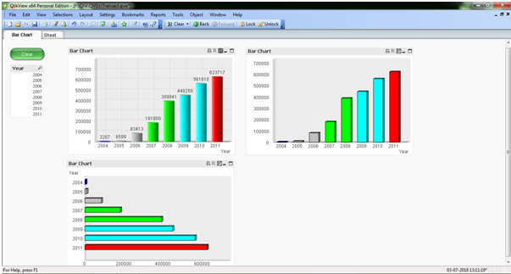](https://1000projects.org/wp-content/uploads/2018/07/Bar-Chart-of-Sales-Analysis.png)

In the above screen, it shows the different types to represent the Bar Chart (Sum of Sales per Year)

**Pie Chart:**

A pie chart (or a circle chart) is a circular statistical graphic which is divided into slices to illustrate the numerical proportion

[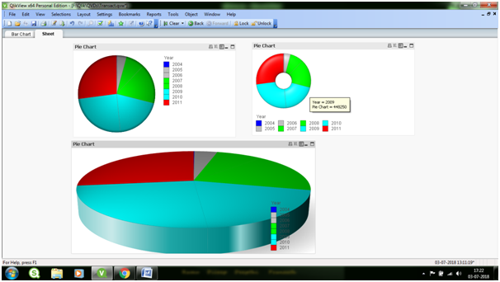](https://1000projects.org/wp-content/uploads/2018/07/Pie-Chart-of-Sales-Analysis.png)

In the above Screen, it shows the different ways to represent the Pie chart (Sales per Year)

**Pivot Table:**

Pivot Tables are widely used in data analysis to present the sum of values across many dimensions available in the data.

[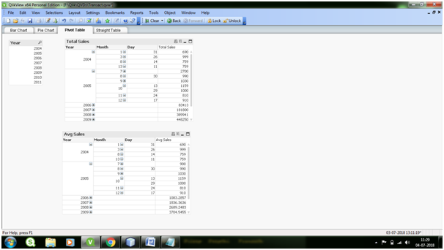](https://1000projects.org/wp-content/uploads/2018/07/Pivot-Table-of-Sales-Analysis.png)

**Straight Table:**

Straight Tables are the most widely used sheet object to display data in QlikView. They are very simple yet powerful with features like column rearrangement, sorting and coloring the background etc.

[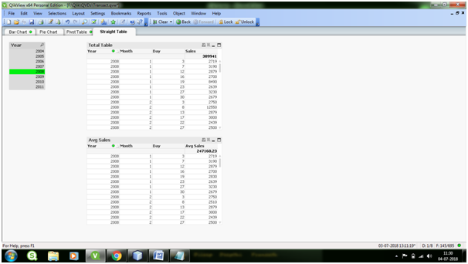](https://1000projects.org/wp-content/uploads/2018/07/Straight-Table-of-Sales-Analysis.png)

**Conclusion :**

Product sales analysis is a dynamic and iterative process that empowers businesses to optimize operations, increase revenue, and enhance customer satisfaction. By harnessing the power of data, organizations can stay competitive, adapt to market shifts, and drive long-term success. It is an essential practice for any business committed to thriving in a constantly evolving marketplace